Handbook2 for Project
All For Mountains

This manual Book will useful when you pass all steps from Handbook1

For this project you are required to create aHTML5/JavaScript application in NetBeans IDE.

The first part of the project is based on CreateShopDatabase will create the MySQL Tables. The Tables will contain :
1. the products for sale
2. the user’s credentials
3. the delivery details
To work as expect this project should contain servlets: CreateDatabase.java >> and then need to RUN InsertData.java fille to insert products to the table products .

The second part of the project based on RegistionForm will create a database for customers to register. It should contain a register.html , register.jsp page which is connected to a RegisterServlet.java.

The third part of the project based on LoginForm will allow registered customers to login into the online shop where they can search and order goods. This will use a login.html, LoginServlet.java, EshopDisplay,java, QueryServlet.java and OrderServlet.java.

The fourth part of the project based on deliveryServlet it will create a database with Addresses, and details of purchases which user is order. But this function will by proceed, only If user will complete the payment. This will use a DeliveryDervlet, LoginServlet, EshopDisplay,QueryServlet and OrderServlet.java, cart.jsp , order_review_page.jsp, and deliveryTable in database.

Contact Us is fifth part based on the ContactServlet it will create a database in MySQL. If user want to leave his Message about his experience use our site or leave some complaints, it can use ContactUs Page. This will use a contact.html, contacts table in mountains_shop database.

The aHTML5/JavaScript application Project should include the following files

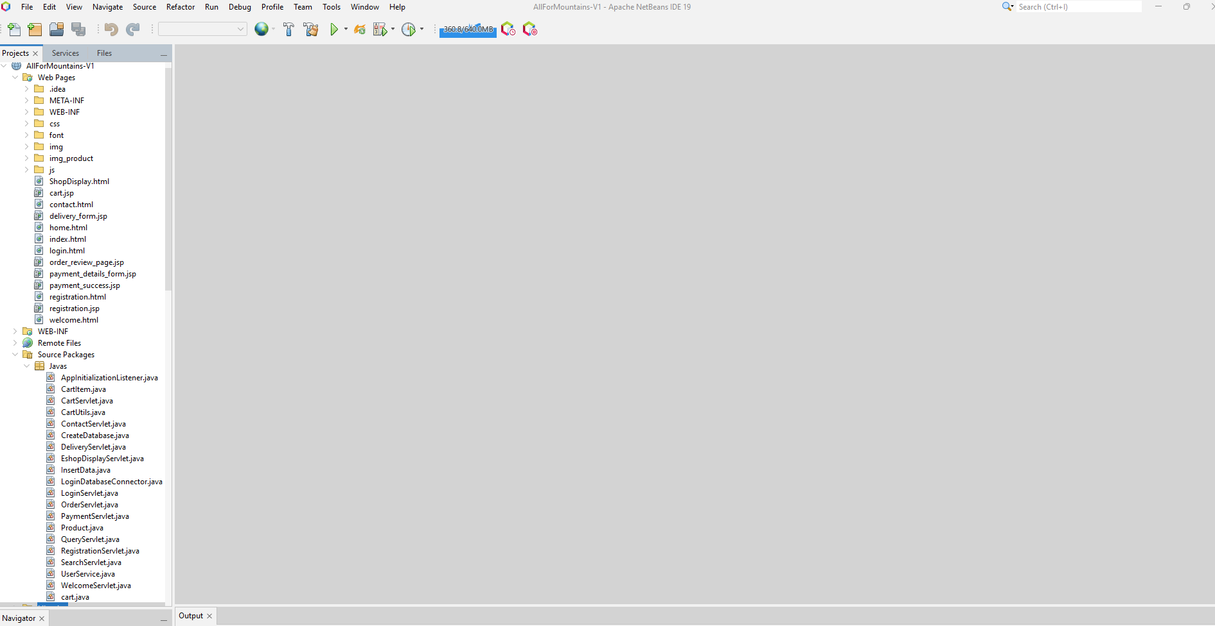

The sample of the Web Database App in operation.
The first page should welcome the user and offer login or registration options. If the user registers, they should be added to the user database. After a successful login the user should be directed to the shop display where they can order goods. when the user has selected their products . It's should proceed to the cart page, where he can remove the goods if hi changed my mind or add more goods using back button to proceed to shop page. Then user need to finished the payment, to proceed forward.

index.html

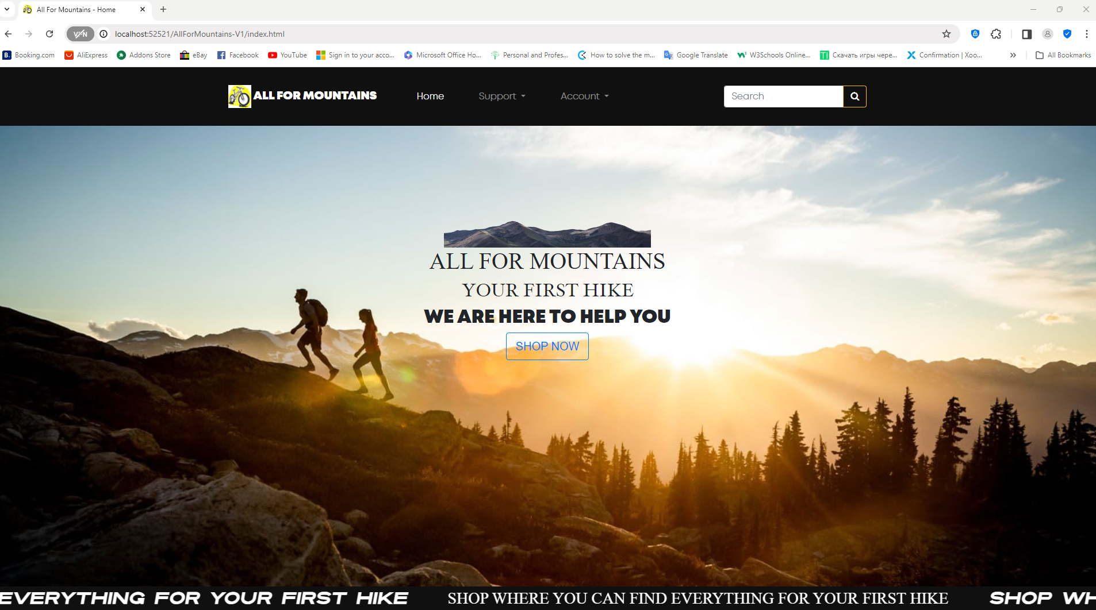

register.html
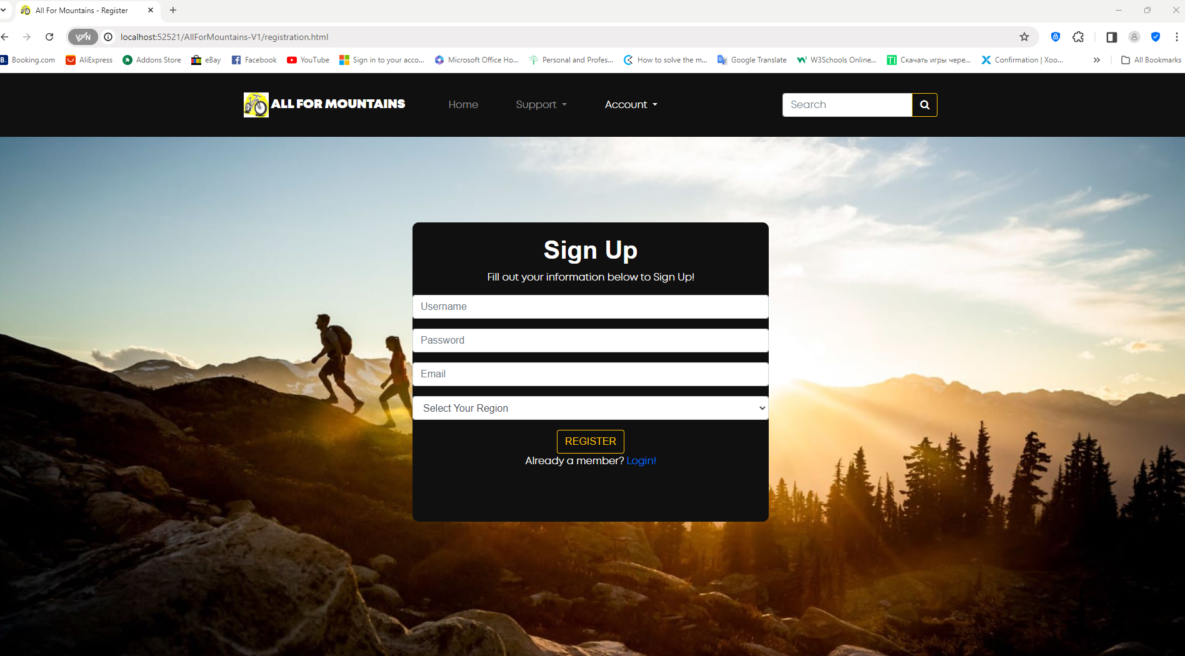

login.html
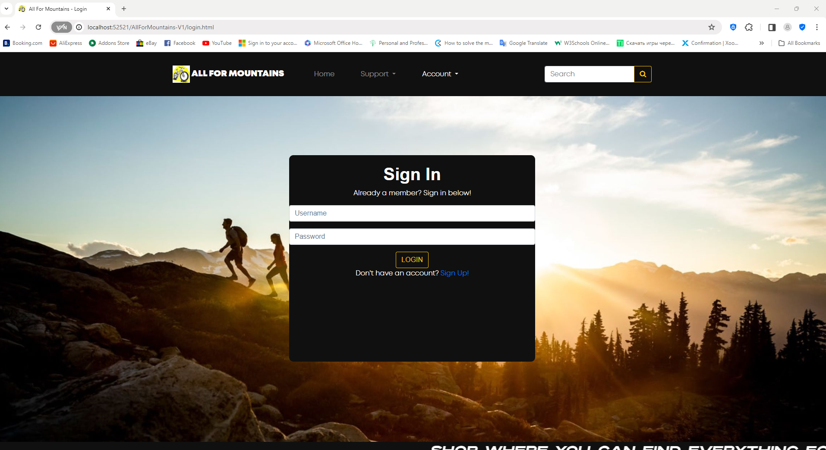

Welcome.html
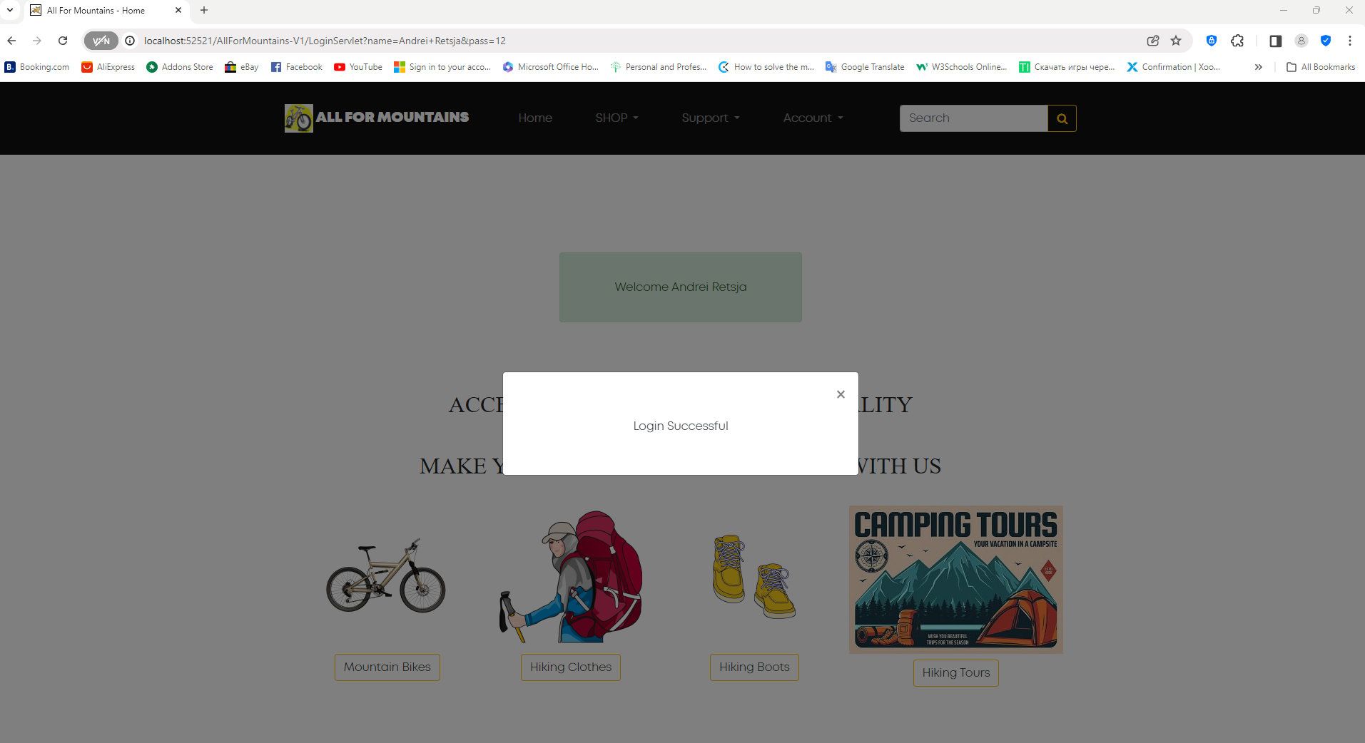

QueryServlet: 1
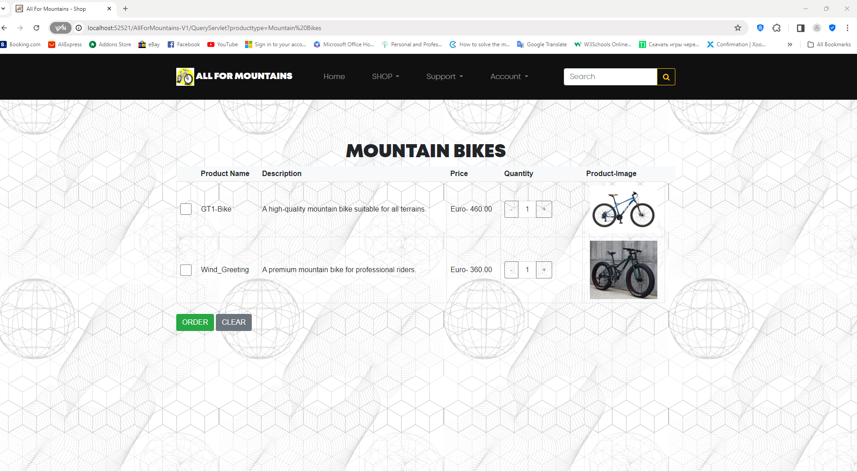

QueryServlet: 2
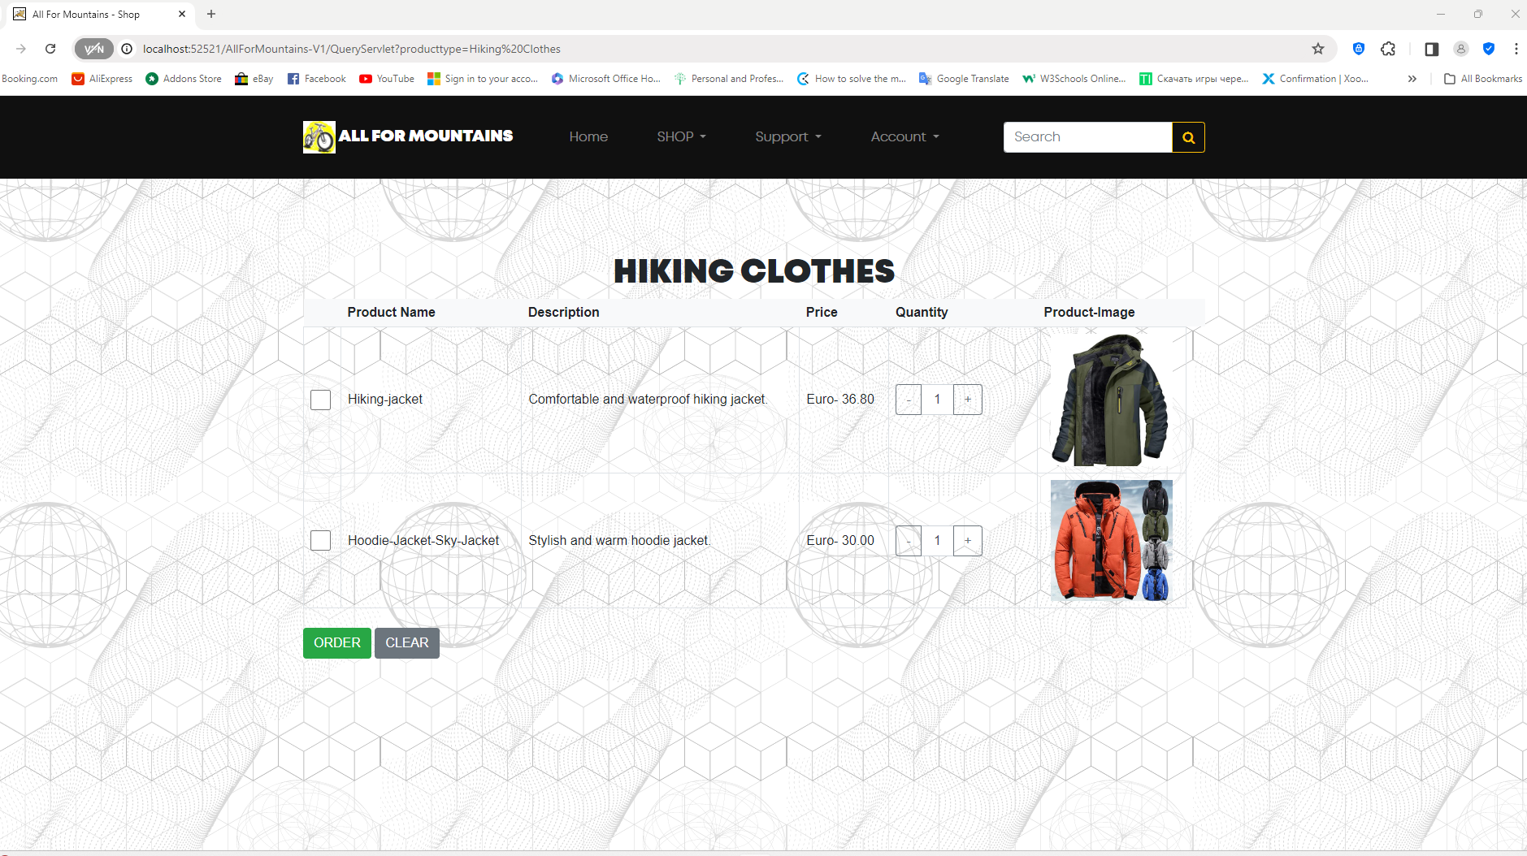

QueryServlet: 3
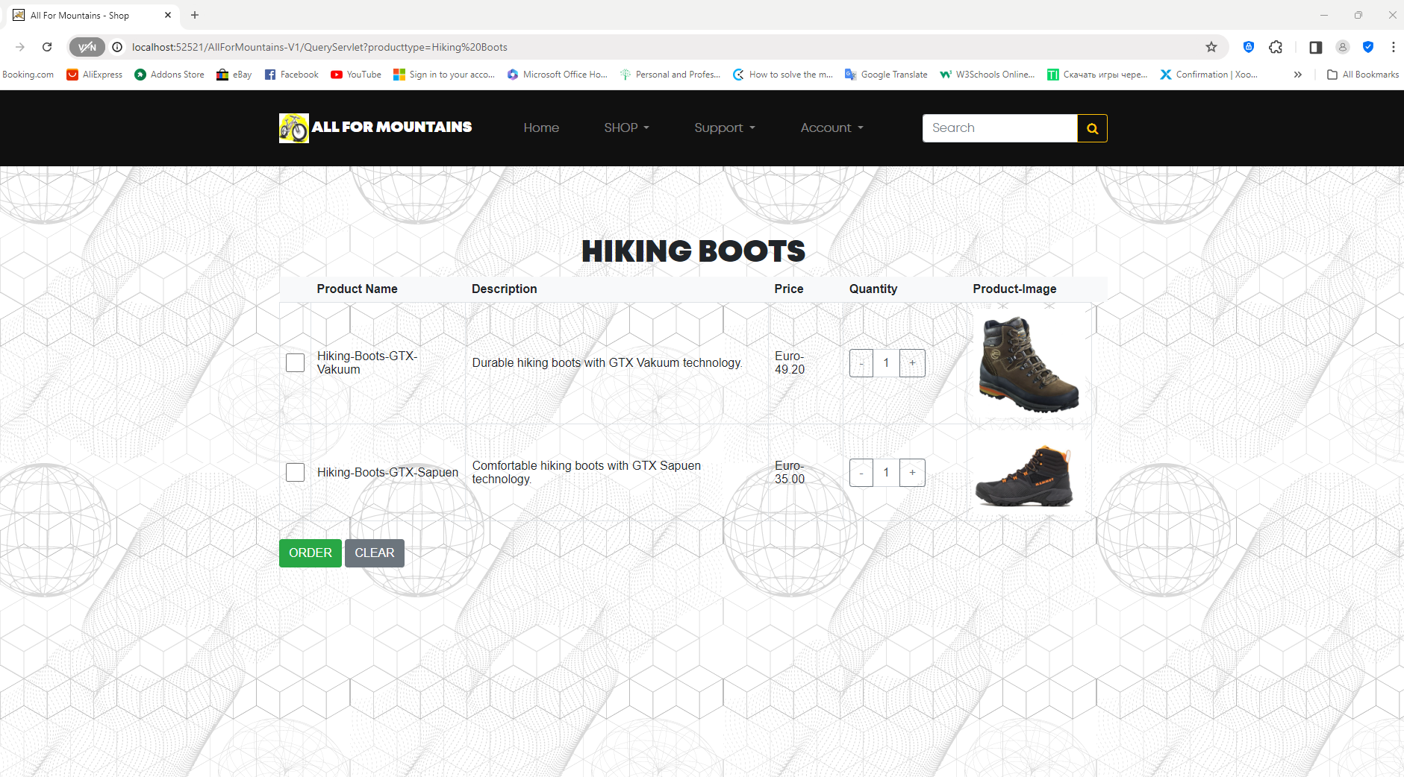

QueryServlet: 4
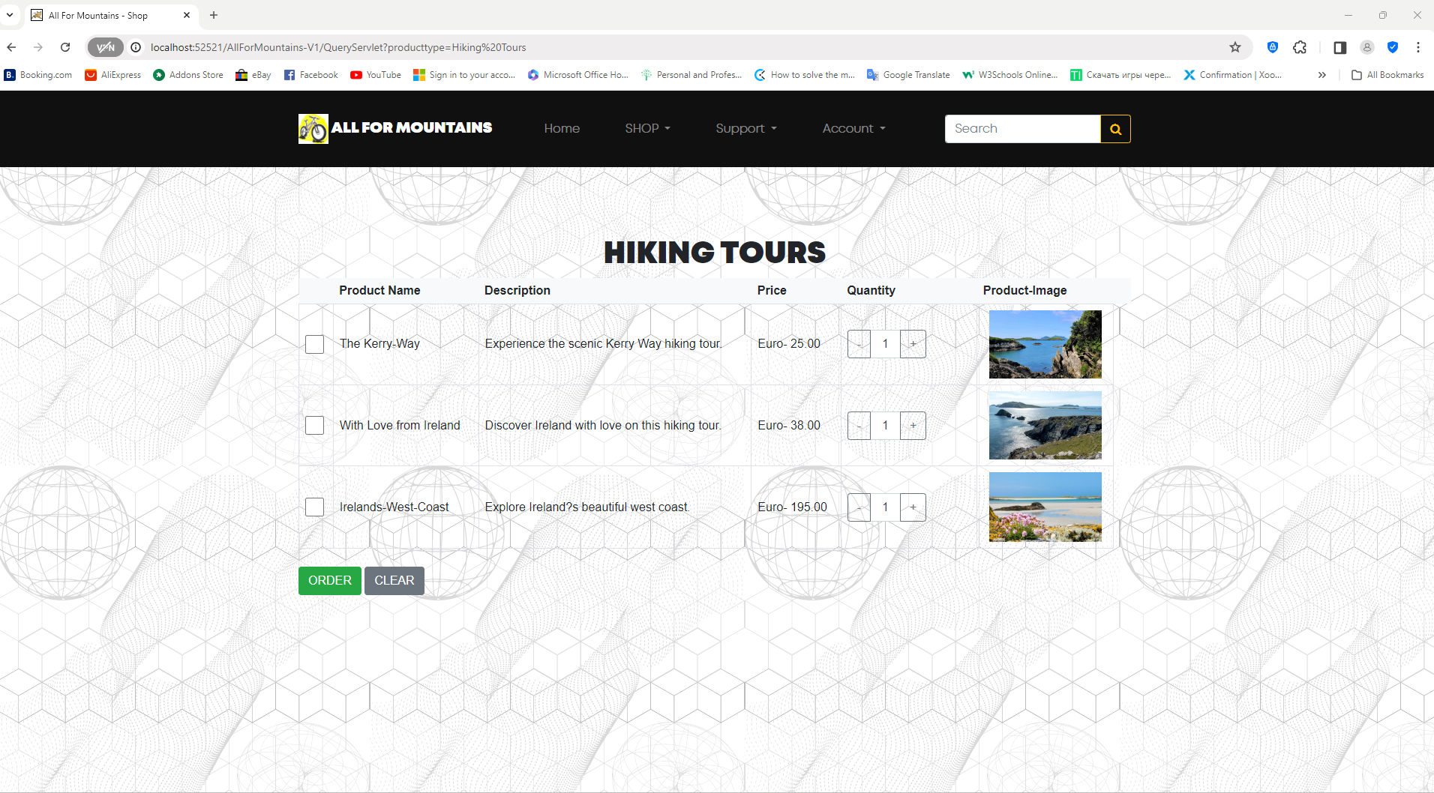

Cart
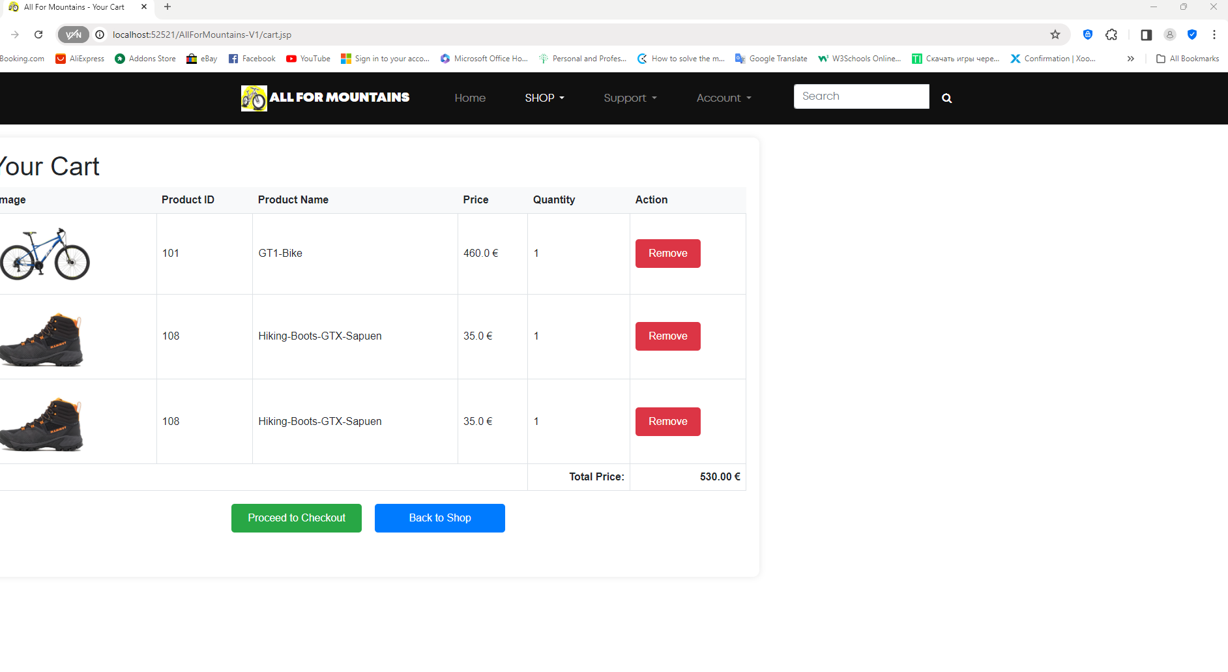
OrderServlet
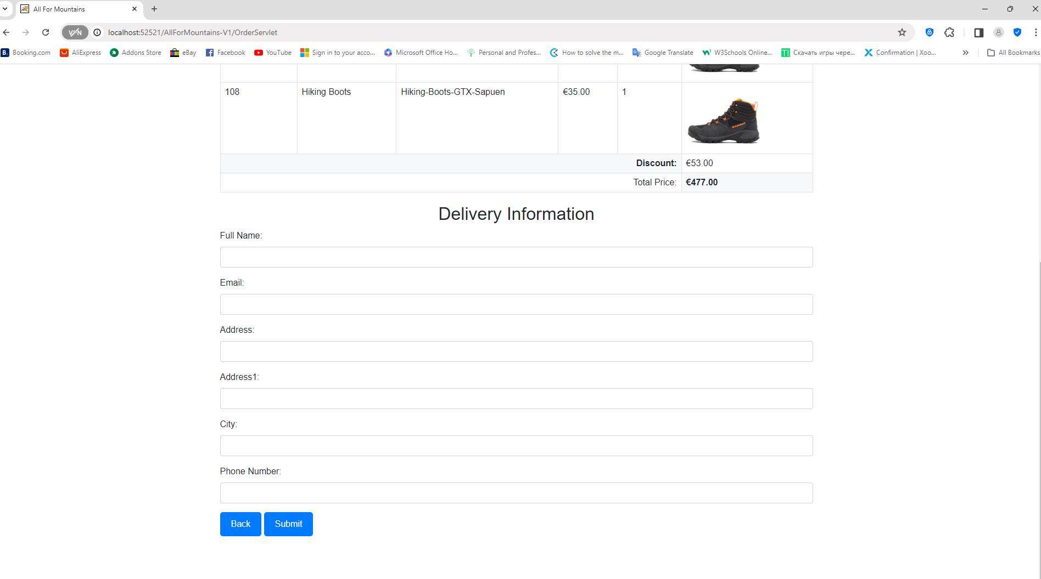

DeliveryServlet
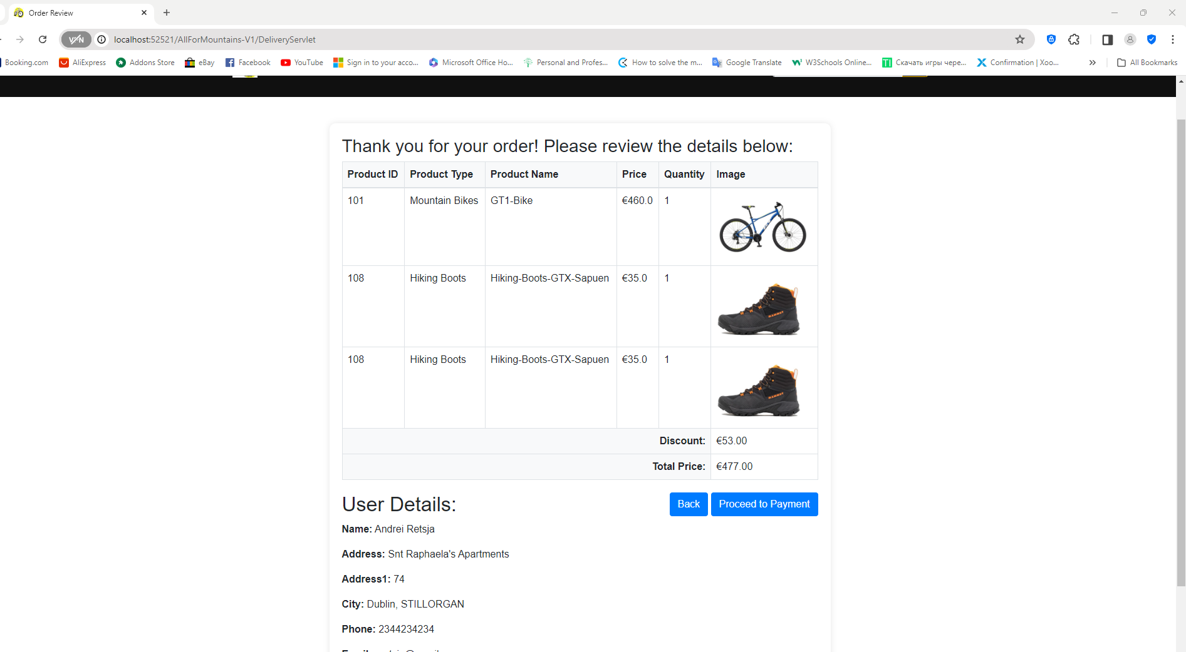

payment_details_form
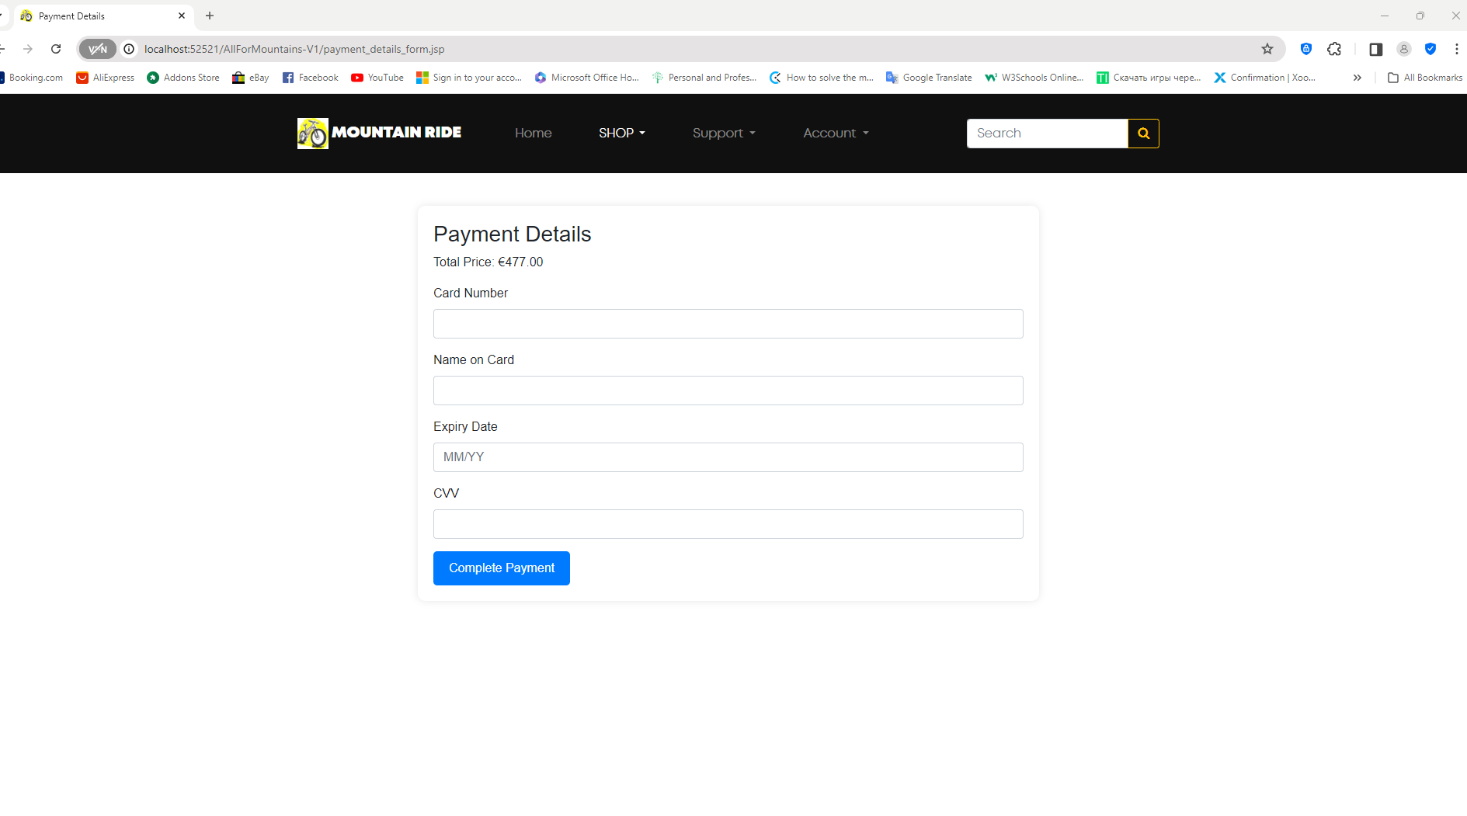

payment_success

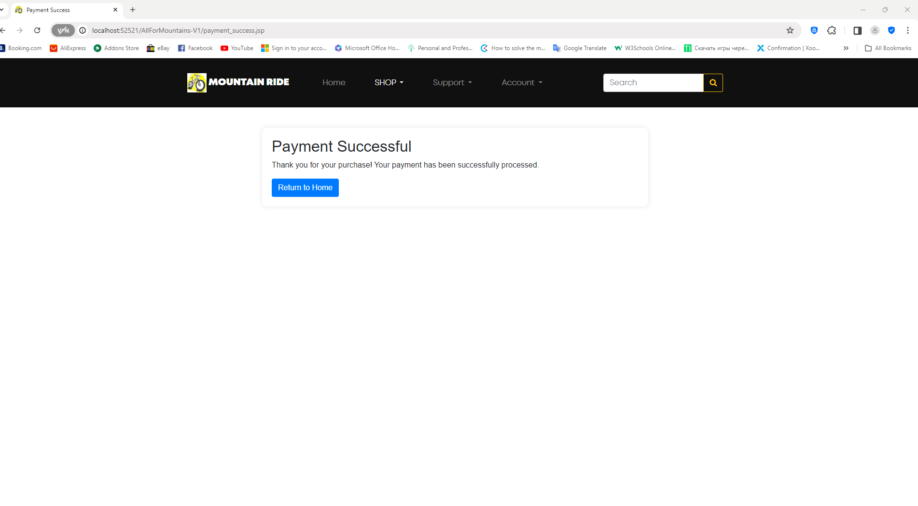

contact.html
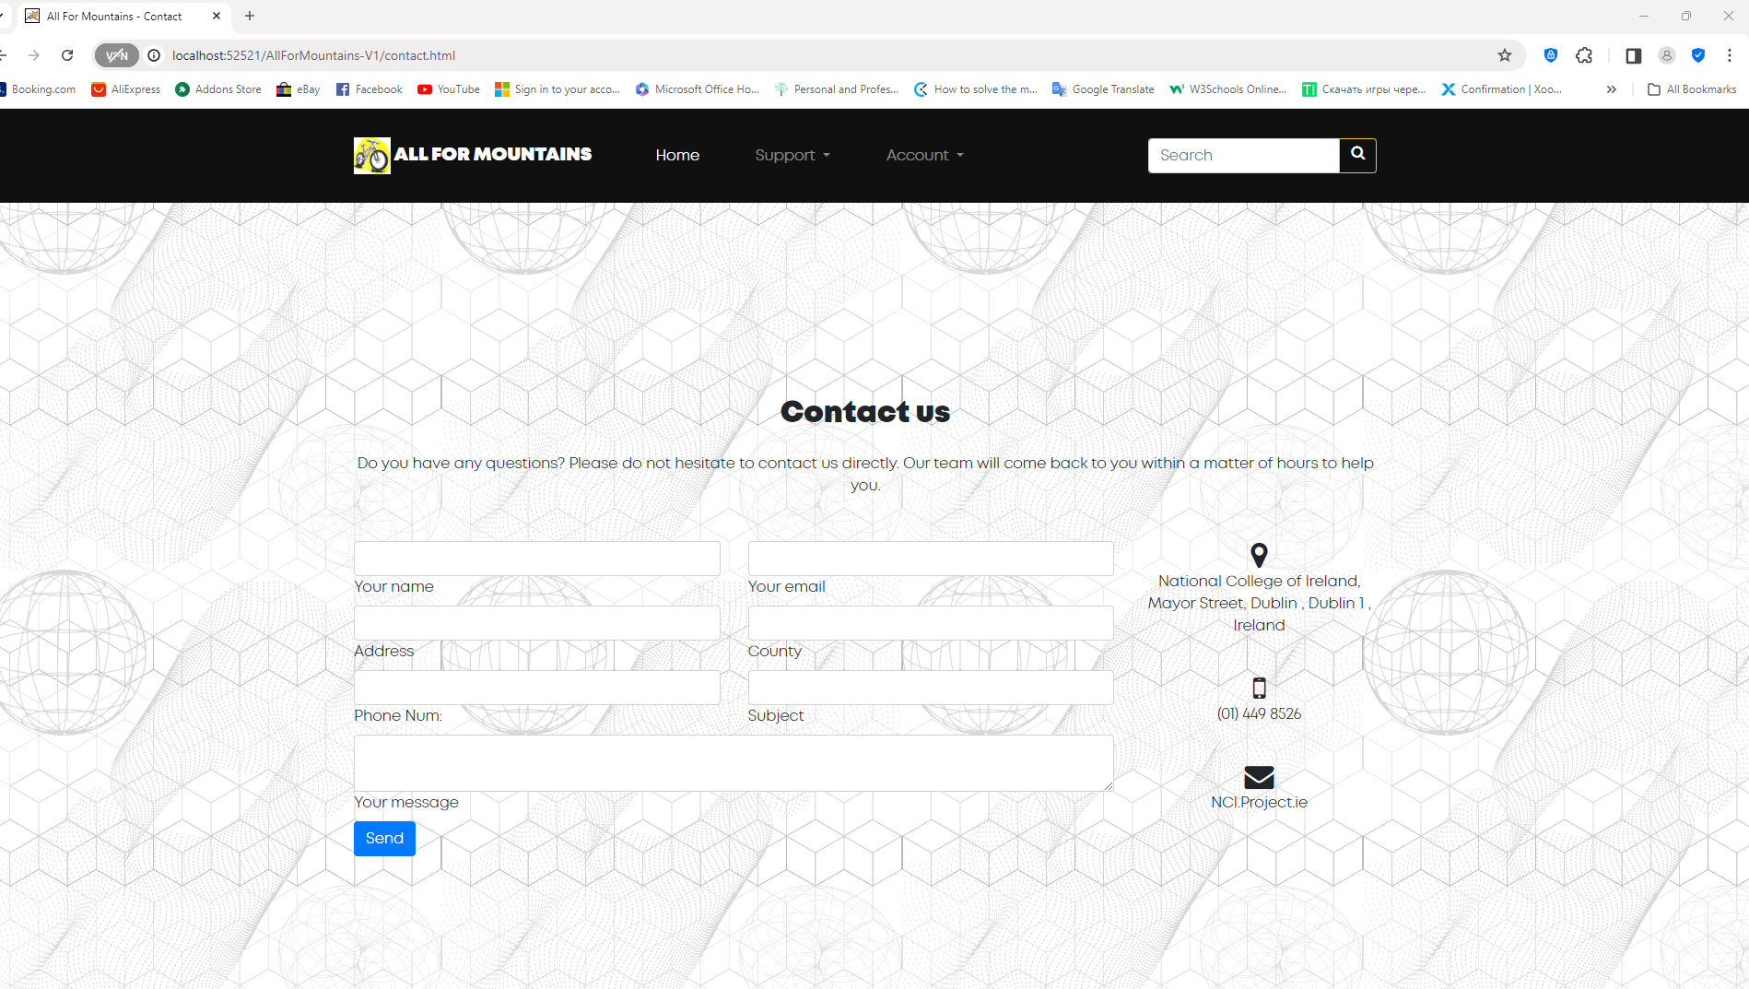

ContactServlet
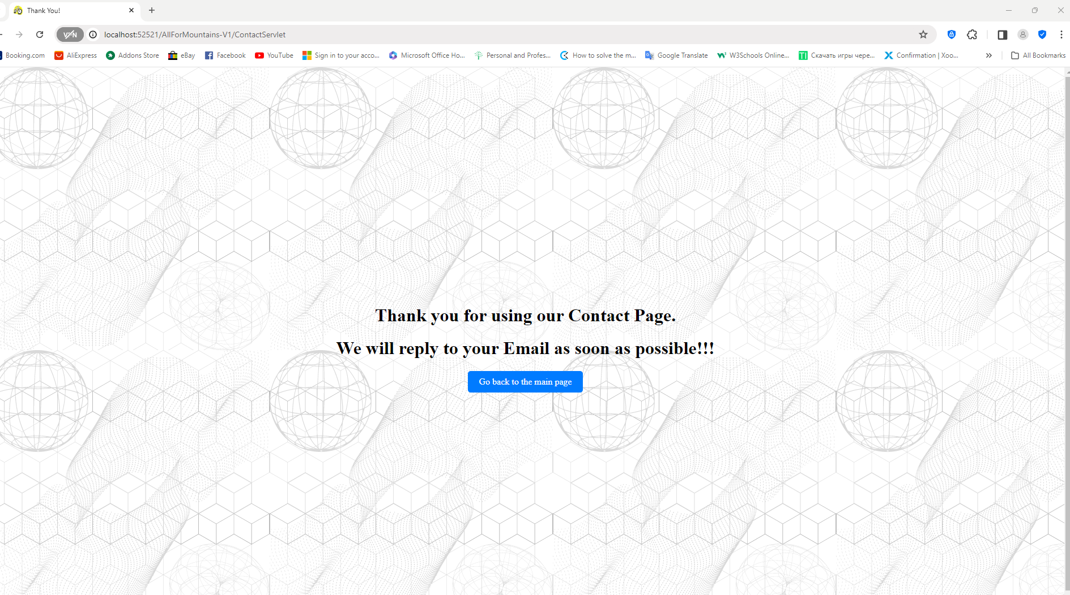

The following screen shots show the creation and use of the shop database and its four tables.

When you Run-File CreateDatabase.java
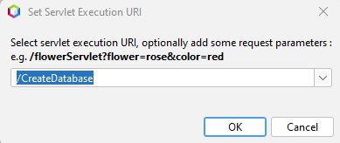
Press >> OK
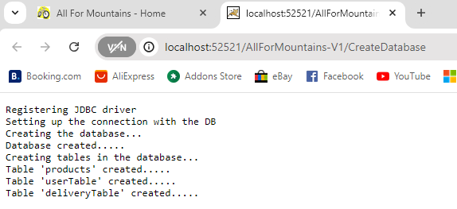

When you Run-File InsertData.java
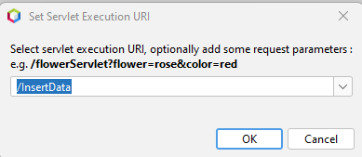
Press >> OK
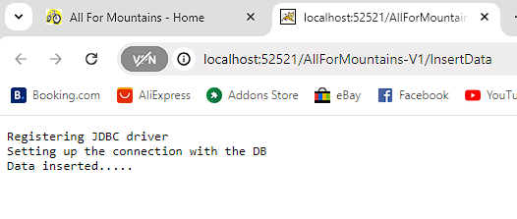
Database snips:


